

INTEGRATED CODING EDUCATION & COMPETITIVE PROGRAMMING PLATFORM

Software Requirement Specification

Table of Contents:
1. INTRODUCTION 4
1.1 Purpose 4
1.2 Scope 4
1.3 Glossary of Terms 5
1.4 References 7
1.5 Document Structure Overview 7
2. OVERALL DESCRIPTION 8
2.1 System Context Diagram 8
2.2 Characteristics and Roles of Users 9
3. FUNCTIONAL REQUIREMENTS 10
3.1 System Features List 10
3.1.1 Guest Function 10
3.1.2 Functions for Customers (Students) 11
3.1.3 Functions for Instructors 12
3.1.4 Functions for Admins (Administrators) 13
3.1.5 Functions for Judge0 (System Agent) 13
3.2 High-level Use Case Diagram 14
3.3 Detailed Use Case Diagrams 15
3.3.1 Decomposing the Guest Actor Use Case 15
3.3.2 Decomposing the Customer Actor Use Case 16
3.3.3 Decomposing the Instructor Agent Use Case 17
3.3.4 Decomposing the Admin Actor Use Case 18
3.3.5 Decomposing the Judge0 System Interaction Use Case 19

Table of Figures:
Figure 2.1 Overview use case diagram 14
Figure 2.2 Guest use case diagram 15
Figure 2.3 Customer use case diagram 16
Figure 2.4 Instructor use case diagram 17
Figure 2.5 Admin use case diagram 18
Figure 2.6 Judge0 use case diagram 19

1. INTRODUCTION

1.1 Purpose
This Software Requirements Specification (SRS) document defines in comprehensive detail all functional and non-functional requirements for the "Integrated Coding Education & Competitive Programming Platform". This document serves as a technical guideline to align the development team (SWP391 project group) for designing the architecture, constructing the database, and programming the core modules. Concurrently, it acts as the official technical commitment and acceptance basis between the student group, the supervisor, and the Capstone Project Committee at FPT University. It establishes a standard benchmark to evaluate the actual product quality, ensuring absolute consensus on the system's scope and operational behaviors before proceeding with the coding phase.

1.2 Scope
The project focuses on building a unique hybrid web application platform: combining an online course platform (Udemy model) and a programming practice and competition system (LeetCode/Codeforces model) .
The system comprises the following core functional subsystems:
- E-learning subsystem (Online Management and Learning): Provides a digital space allowing instructors to manage and publish courses, upload video lectures, theoretical PDF documents, and create quizzes to assess student proficiency at each stage.
- The Online Judge subsystem (Automated grading system): Integrates an online programming environment (Web-based IDE) supporting multiple languages (C++, Java, Python...). This subsystem connects directly to the open-source Judge0 sandbox system to securely execute the learner's (customer's) code, perform testing based on predefined test cases, and provide real-time results.
- Community & Contest Subsystem: Creates an interactive space through Q&A (Question and Answer) boxes under each lesson and a forum for sharing algorithms. Organizes online programming contests with strict time limits, automatically calculates scores, and updates the leaderboard in real time (Live Leaderboard).
- The Administration subsystem provides centralized management tools for administrators to control user accounts, approve/remove instructor courses, manage the global exam question bank, configure the payment system, and monitor revenue/profit statistics charts.

1.3 Glossary of Terms

Terminology / Abbreviations | Definition and Usage Context
SRS | Software Requirements Specification – Software Requirements Specification Document.
Online Judge (OJ) | The software system automatically checks, executes, and evaluates the correctness of a computer program (user-submitted source code) based on logical constraints.
Judge0 | Open-source systems provide a robust API architecture, allowing for the secure execution of source code from various programming languages within an isolated environment (sandbox).
Sandbox | Isolated virtualized environments (often using Docker) are used to run code from unknown sources to prevent malware from interfering with or damaging the main server system.
Contest | The online programming competition/exam takes place within a fixed time frame. Contestants must solve a set of algorithmic problems within the allotted time to compete for rankings.
TestCase | The test dataset includes: Sample input data (Input) and the corresponding expected output (Output) used as a measure to evaluate the correctness of the source code.
AC (Accepted) | The grading status indicates that the learner's source code has passed all test cases correctly and validly.
WA (Wrong Answer) | The grading status indicates that the source code executed successfully, but the output did not match the expected output of the test case.
TLE (Time Limit Exceeded) | The grading status indicates that the program has exceeded its maximum allowed execution time (e.g., by more than 1.0 second) due to poor optimization of the algorithm (infinite loop or excessive time complexity).
MLE (Memory Limit Exceeded) | The grading status indicates that the program is using more RAM than the maximum amount configured for the problem (e.g., > 256MB).
Live Leaderboard | The live leaderboard displays the ranking, number of solved problems, and penalty time of all contestants in the Contest, updated in real time as new entries are submitted.
JWT | JSON Web Token – A standard encrypted string used to authenticate secure access between the frontend and backend after a user successfully logs in.

1.4 References
The process of analyzing and developing this SRS document involved referencing the following technical documents and technology standards:
- International Standard for Requirements Specification: ISO/IEC/IEEE 29148:2018 Systems and software engineering — Life cycle processes — Requirements engineering.
- Software Development Guide for SWP391 Course: Textbook and guide for writing SRS issued by the Software Engineering Department - FPT University.
- Judge0 API technical documentation: Official Documentation of Judge0 v1.13.0 for code execution syntax & sandbox architecture (https://ce.judge0.com/).
- The Spring Boot & PostgreSQL architecture specification documents: Spring Framework Reference Documentation and PostgreSQL Core Documentation are used to compare data binding configurations.

1.5 Document Structure Overview
This SRS document is divided into five major logical chapters, making it easy for readers to understand the system from overview to detail:
- Chapter 1: Introduction: This chapter introduces the purpose, scope of application, specialized terminology dictionary, references, and overall structure of the document.
- Chapter 2: Overall Description: Provides an overview of the system through a context diagram, detailing the characteristics and roles of each actor (Guest, Customer, Instructor, Admin, Judge0) and outlining the technical assumptions and dependencies.
- Chapter 3: Functional Requirements: This is the core chapter, including a detailed list of functional permissions, an overview Use Case diagram, broken down Use Case diagrams for each actor, detailed Use Case specifications (main event flow, alternative flow) for core features, and a list of mandatory Business Rules that the system must adhere to.
- Chapter 4: Non-functional Requirements: Defines mandatory technical standards for usability (UI/UX), operational performance and load capacity, security mechanisms (JWT, class-based authorization), reliability, and system security when running unfamiliar source code.

2. OVERALL DESCRIPTION

2.1 System Context Diagram
The context diagram describes the "Integrated Coding Education & Competitive Programming Platform" system as a black box in a central location, interacting with external entities.
- Central System: Online Programming Learning and Competition Platform.
- Entities that interact directly:
  - Customer: Submits course purchase requests, submits solution source code, queries leaderboard , and receives video lecture streams.
  - Instructor: Submit requests for permission to sell courses, upload lesson content/Contest questions, and receive sales reports.
  - Admin: Receive system alerts, send decisions to approve/reject Instructor permissions, manage cash flow across the entire platform.
  - Judge0 Sandbox (External API): The system sends source code along with test cases; Judge0 compiles, runs the tests, and returns the status (AC/WA/TLE).

2.2 Characteristics and Roles of Users
The system is designed for multiple users, serving four main user groups and one automated system:

Agent | Classify | Key Features and Roles
Guest​ | The user is not logged in. | Users can access the platform to view introductory information, search for course listings, watch demo videos, and browse a list of publicly available algorithm assignments, but they cannot submit assignments or purchase courses. The main purpose is to convert Guests into Customers.
Customer (Student) | The user is logged in. | They are a revenue-generating customer segment for the platform. They have personal wallets and the right to deposit/pay to purchase courses. In terms of algorithms, they have the right to use the Web IDE to submit code to solve problems and register to participate in contests to compete on the leaderboard.
Instructor (Freelance Instructor) | Partner users (Requires approval) | They operate like sellers on an online marketplace (Udemy model). Initially, they are customers who must submit an application for access. Once approved by the admin, they have their own space to upload videos, create quizzes, start contests, configure programming exercises, set their own course prices, and withdraw revenue to their personal bank accounts.
Admin​ | Platform management team | As the ultimate coordinator of this educational marketplace, the Admin does not directly sell courses but acts as a moderator (approving instructor permissions, reviewing course content to prevent violations), managing the overall exam question bank, moderating the forum, and managing revenue sharing (e.g., taking a 30% commission from instructors).
Judge0 API | System Actor | The automated server platform handles programming language compilation tasks (C++, Java, Python, etc.), runs tests within time/memory constraints, and returns the results to the main server.

3. FUNCTIONAL REQUIREMENTS

3.1 System Features List

3.1.1 Guest Function
A guest is a user who is not logged in and can experience the basic features of the platform to learn about it before deciding to become a full student.
- View homepage : Access the system's main interface.
- Register an account : Create a new account on the platform.
- Login : Verify your information to access the system as a Customer.
- Search and view course information : Find available courses and view detailed course descriptions.
- View the lesson (Demo) : Watch 1-2 demo videos and preview the course program/syllabus.

3.1.2 Functions for Customers (Students)
Customers are logged-in users, and they are the central focus of the system, with rights related to learning and competition:
- Manage your personal account :
  - Log out of the system.
  - Edit profile (update personal information, avatar).
  - Change password.
  - Forgot password.
- Discover and Pay :
  - Search for courses (filter by name, instructor, price, category...).
  - View your transaction/payment history.
  - Register for the course, make payment, and enroll in the course.
- Learning (E-learning) :
  - Watch the lesson (Video, Document).
  - Take a quiz.
  - Q&A (Questions and Answers, Discussion during the Lesson).
  - Complete lessons and view course progress (Progress tracking).
  - Course rating and review.
- Practice for Online Judge :
  - Search and filter coding exercises (by difficulty level, tags: Array, DP, String...).
  - Write code using an online code editor.
  - Submit code (Submit your work for the system to grade).
  - View the grading results (Accepted, Wrong Answer, TLE, Memory Limit...).
  - View submission history.
  - View the solution or hint for the code.
  - Discuss and share your solutions in the discussion box for the exercise.
- Participate in the Contest :
  - Participate in the contest and write code using the online code editor.
  - Submit your code and view your real-time score.
  - View your exam submission history.
  - View the contest's live leaderboard/standing.
  - View your individual competition results after the Contest ends.

3.1.3 Functions for Instructors
An instructor is a content provider partner who has the right to create courses and organize algorithm exams.
- Finance & Business :
  - Sell courses.
  - Withdraw revenue.
- Course Management :
  - Manage course content (upload videos, create lessons, create quizzes, etc.).
  - Update, edit, hide/show courses.
  - Answering student Q&A.
  - View course statistics (Number of enrollments, student progress, revenue).
- Contest Management :
  - Create a new Contest (Configure Name, description, start time, duration, password).
  - Add problems to the Contest.
  - View contest statistics and results (list of participants, scores).
- Managing coding assignments (within a specific course) :
  - Create the problem statement (Description, difficulty level, constraints).
  - Create and manage test case sets (Input/Output files).
  - Configure resource limits for the problem (Time limit, Memory limit).

3.1.4 Functions for Admins (Administrators)
The admin is the ultimate coordinator of the system, controlling content quality and cash flow:
- Account management : Grant permissions to instructors and lock/unlock user accounts.
- Course Management : Approve/Reject courses, view violated course rules, and view course statistics (number of courses, number of applicants).
- Contest Management : Grant instructors permission to open contests, close/open contests, and view ranking statistics.
- Payment management : View transaction history, manage revenue/profit across the entire platform.
- General system management :
  - Manage discussion content (Delete violating comments).
  - View system-wide statistics reports (Total users, total courses, number of code submissions, number of contest participations, etc.).
- Assignment Management (Common Question Bank) :
  - Create the problem statement (Description, difficulty level, constraints).
  - Create and manage test case sets (Input/Output files).
  - Configure resource limits (Time limit, Memory limit).

3.1.5 Functions for Judge0 (System Agent)
Judge0 acts as an automated Actor (System Actor), operating silently as an independent arbitrator to process user-generated code:
- Receiving source code : Obtaining the source code and programming language from the backend system.
- Compile & Execute (Sandbox Execution) : Compile and test source code inside a secure virtualized environment (Docker Sandbox) to protect the server.
- Test Case Evaluation : Compare the output of the source code with the standard set of test cases.
- Return status : Sends back to the system the final scoring status including: AC (Accepted), WA (Wrong Answer), TLE (Time Limit Exceeded), or MLE (Memory Limit Exceeded)

3.2 High-level Use Case Diagram
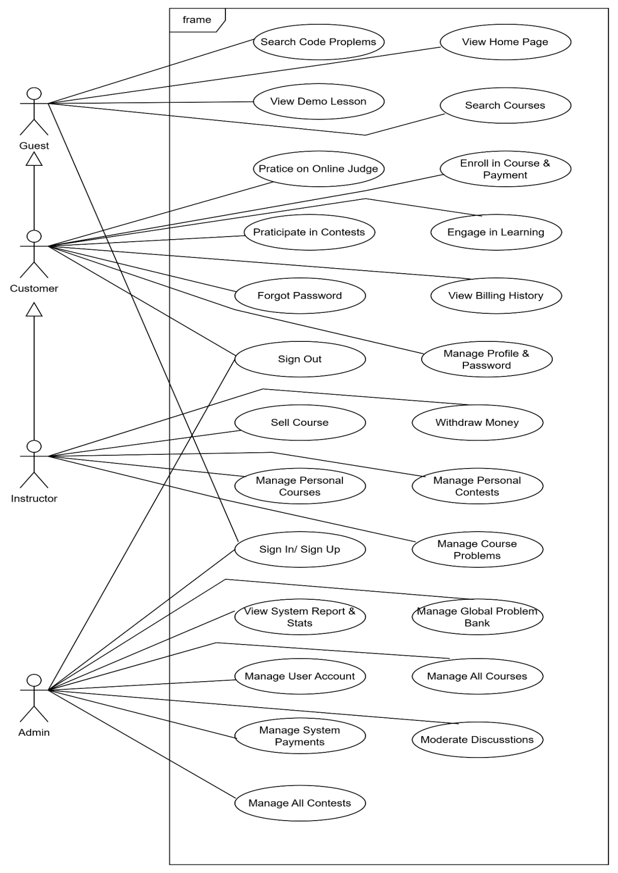
Figure 2.1 Overview use case diagram

3.3 Detailed Use Case Diagrams

3.3.1 Decomposing the Guest Actor Use Case
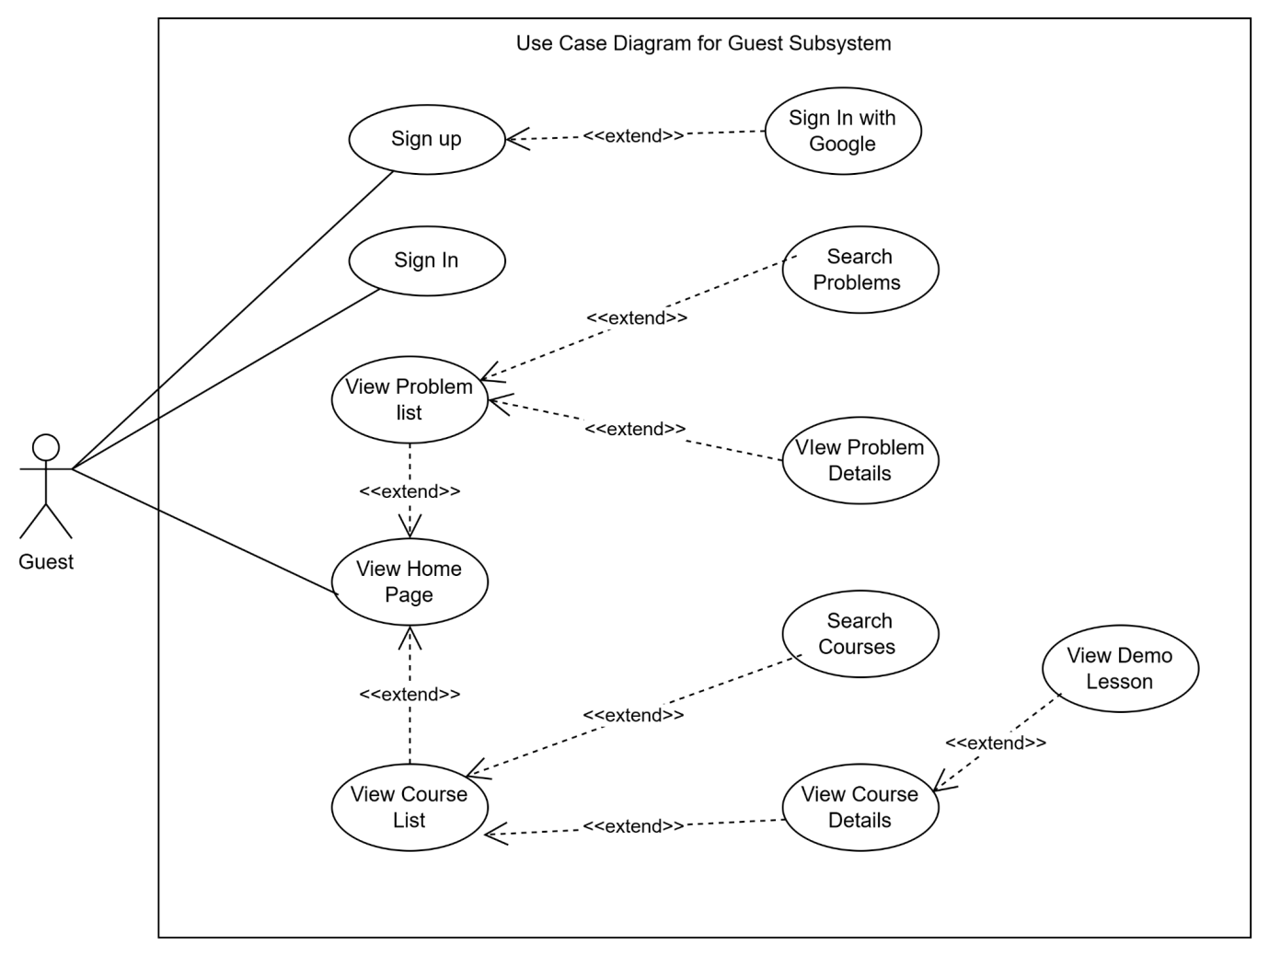
Figure 2.2 Guest use case diagram

3.3.2 Decomposing the Customer Actor Use Case
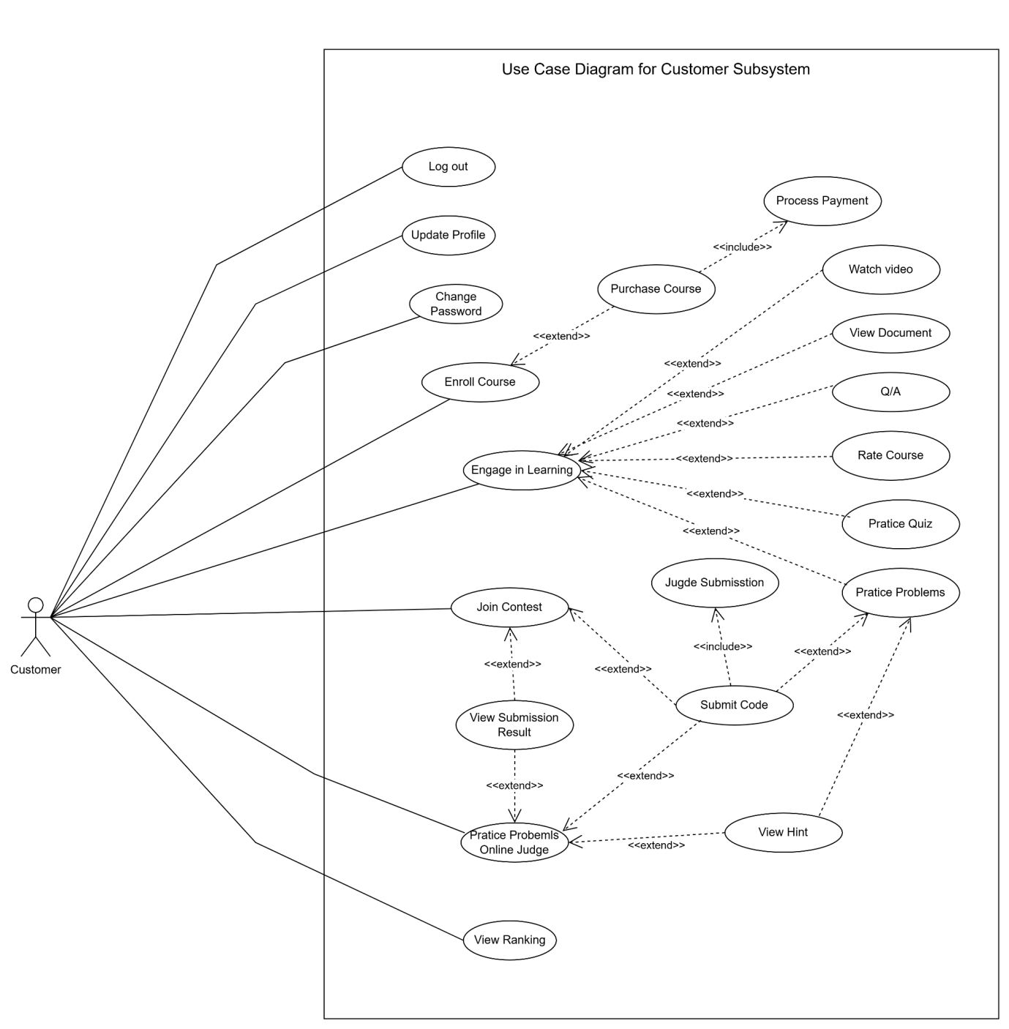
Figure 2.3 Customer use case diagram

3.3.3 Decomposing the Instructor Agent Use Case
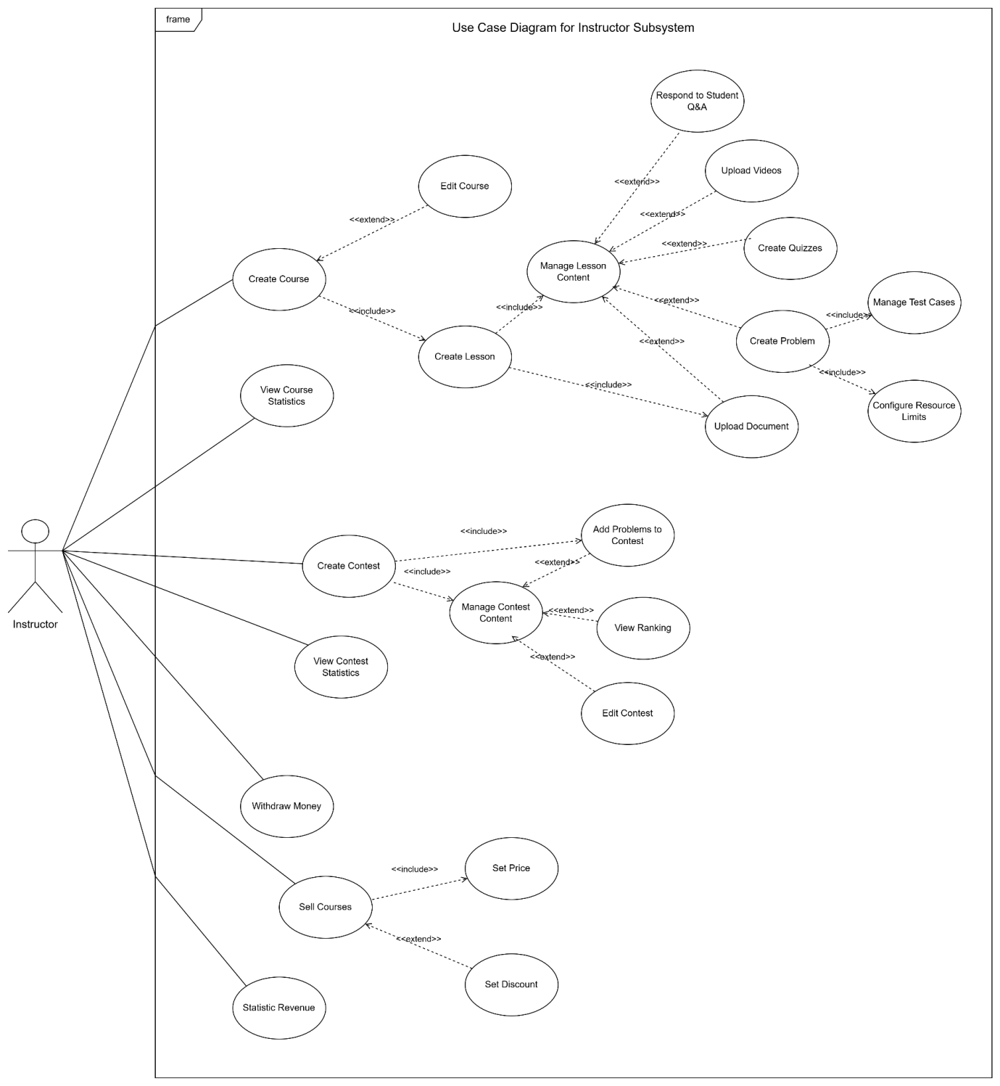

Figure 2.4 Instructor use case diagram

3.3.4 Decomposing the Admin Actor Use Case
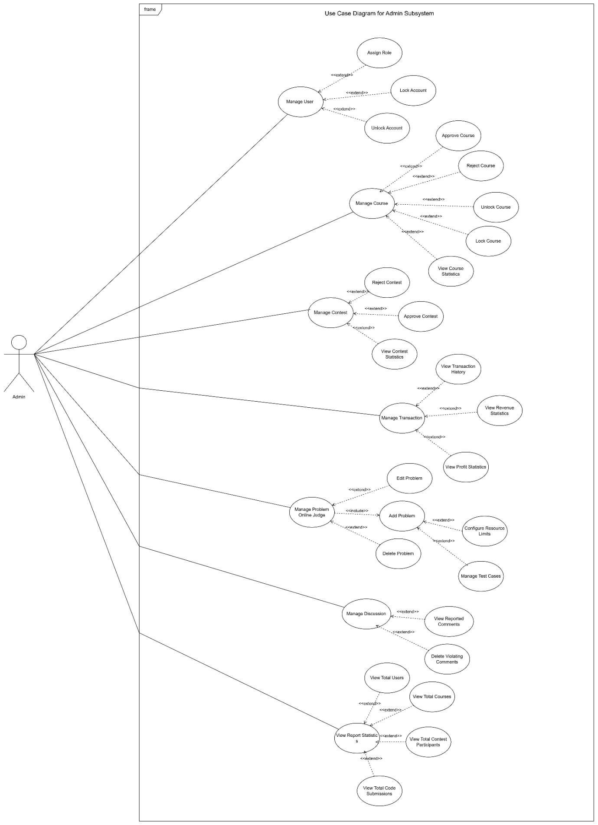
Figure 2.5 Admin use case diagram

3.3.5 Decomposing the Judge0 System Interaction Use Case
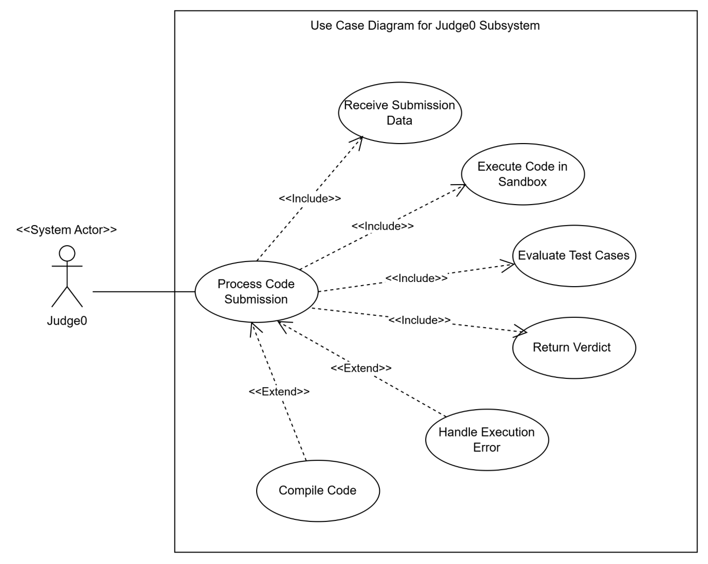
Figure 2.6 Judge0 use case diagram

